Access repository

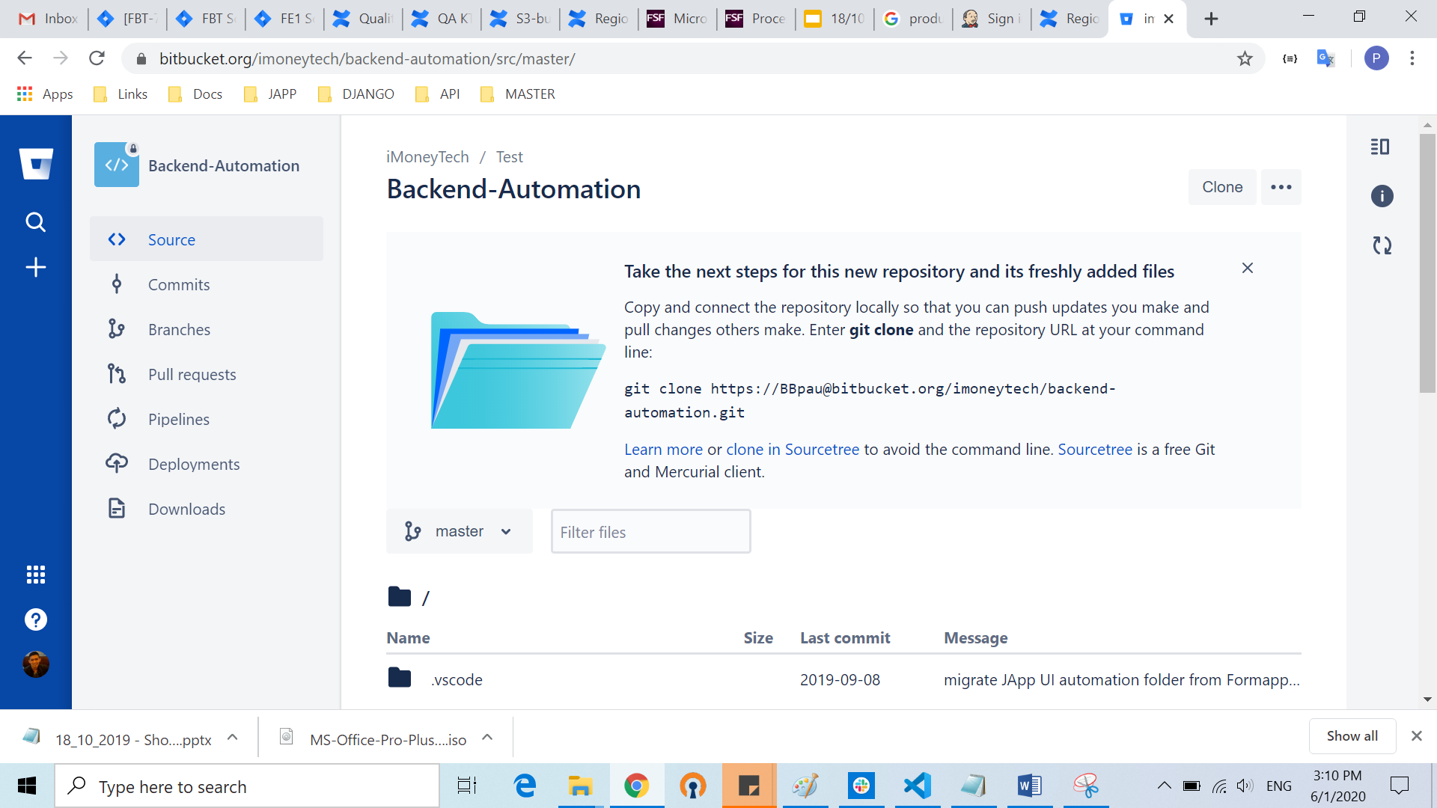

Create Folder in repository

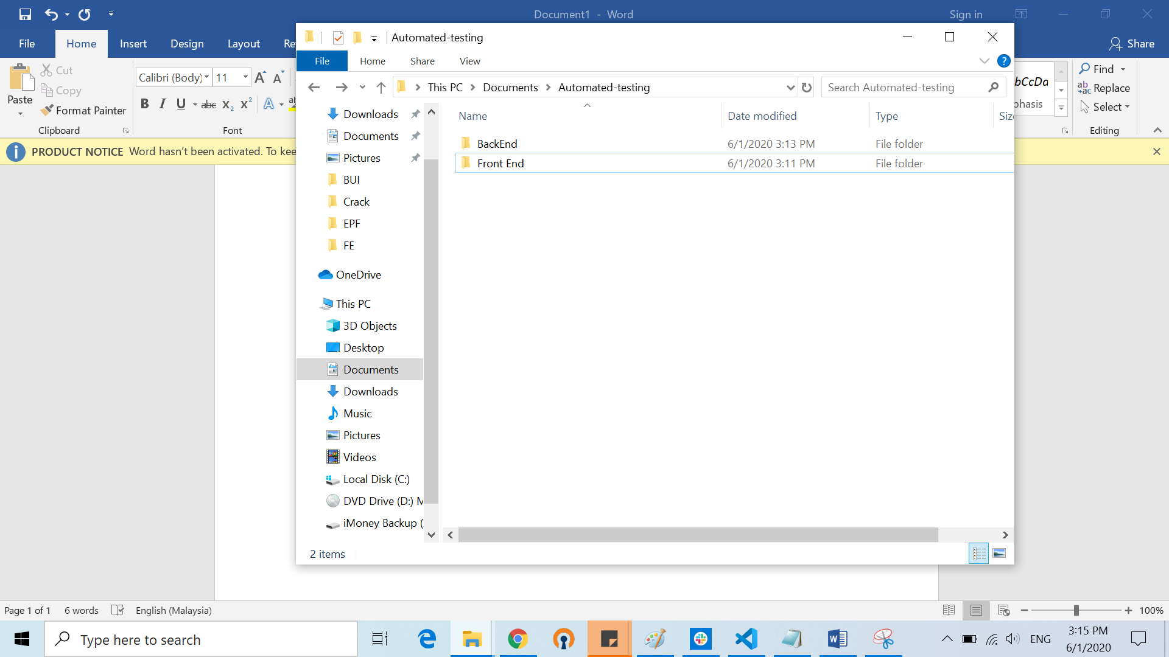

Click Clone

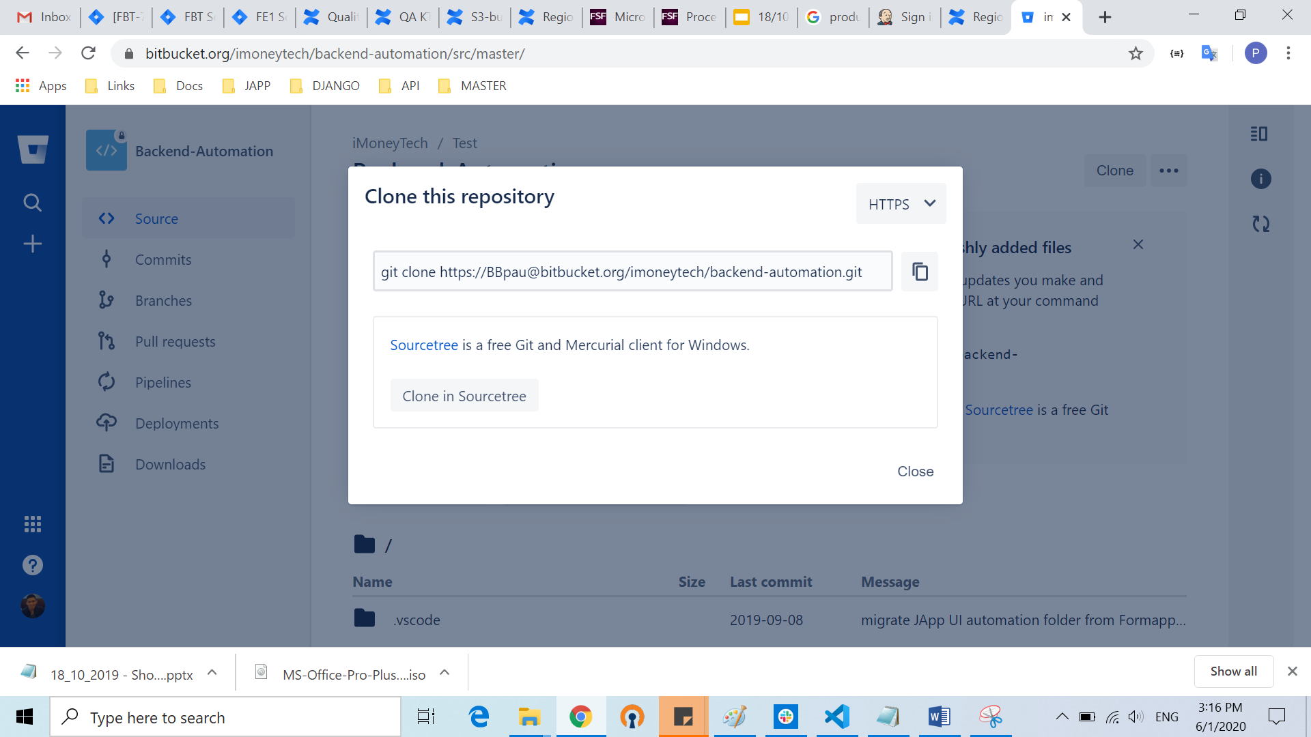

Go to terminal

Copy link

Go to terminal (Git Bash)

Git clone then paste link

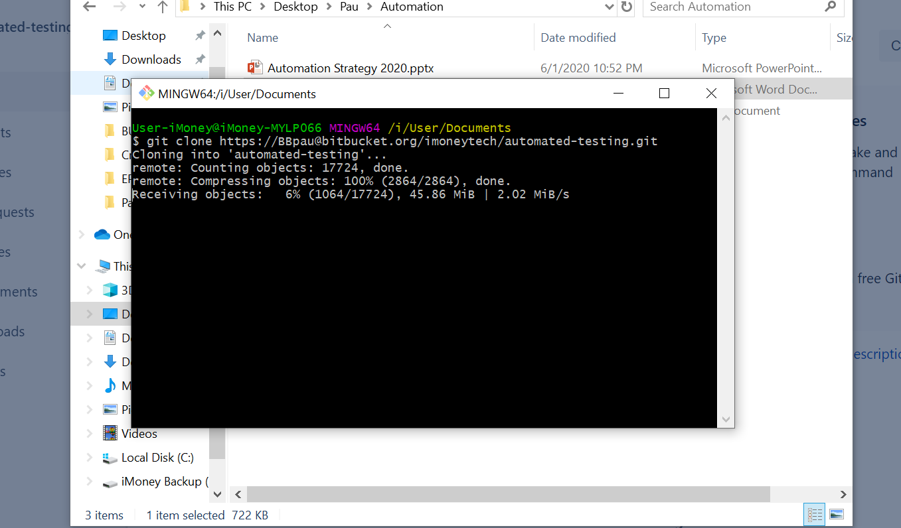

Once done cloning, open code (code .)

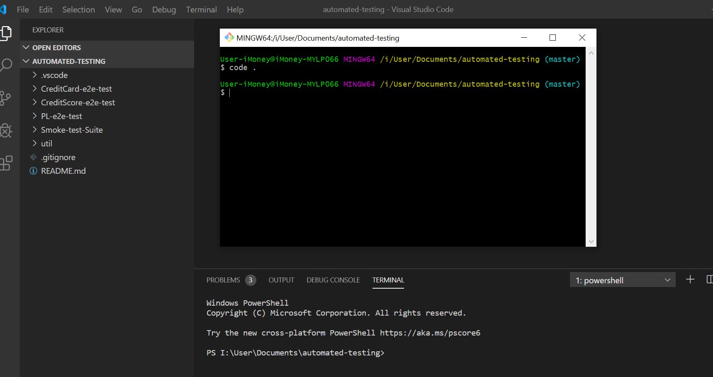

Create local branch

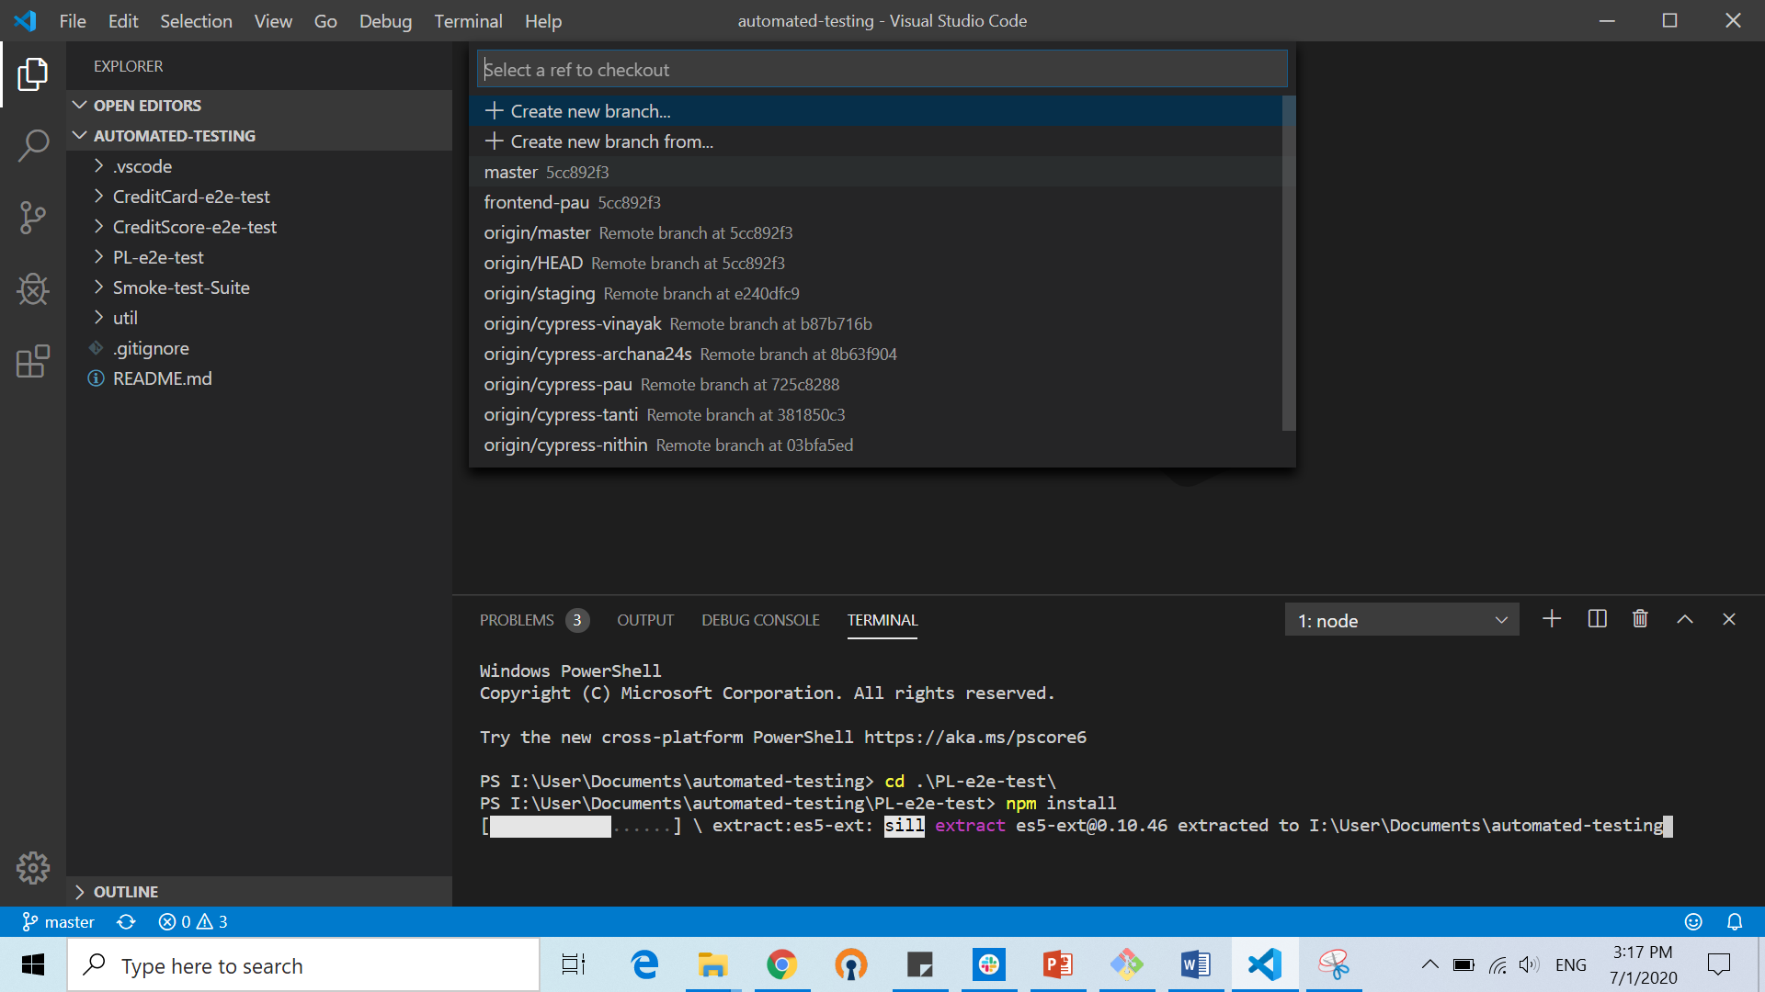

npm install

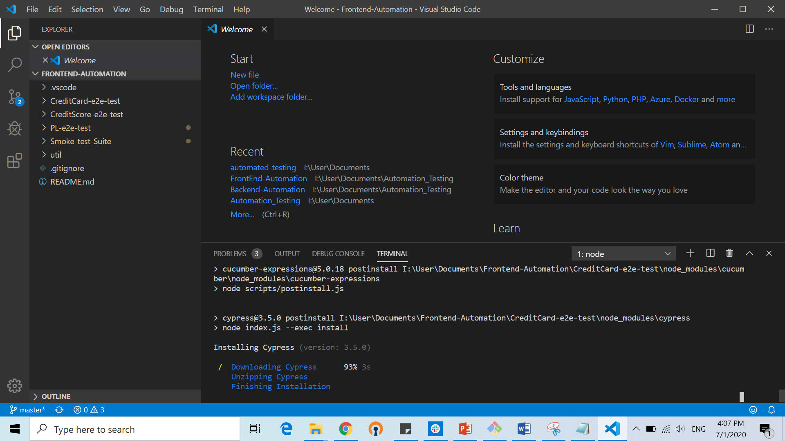

npm link

npm link cypress-cucumber-preprocessor

npx cypress open

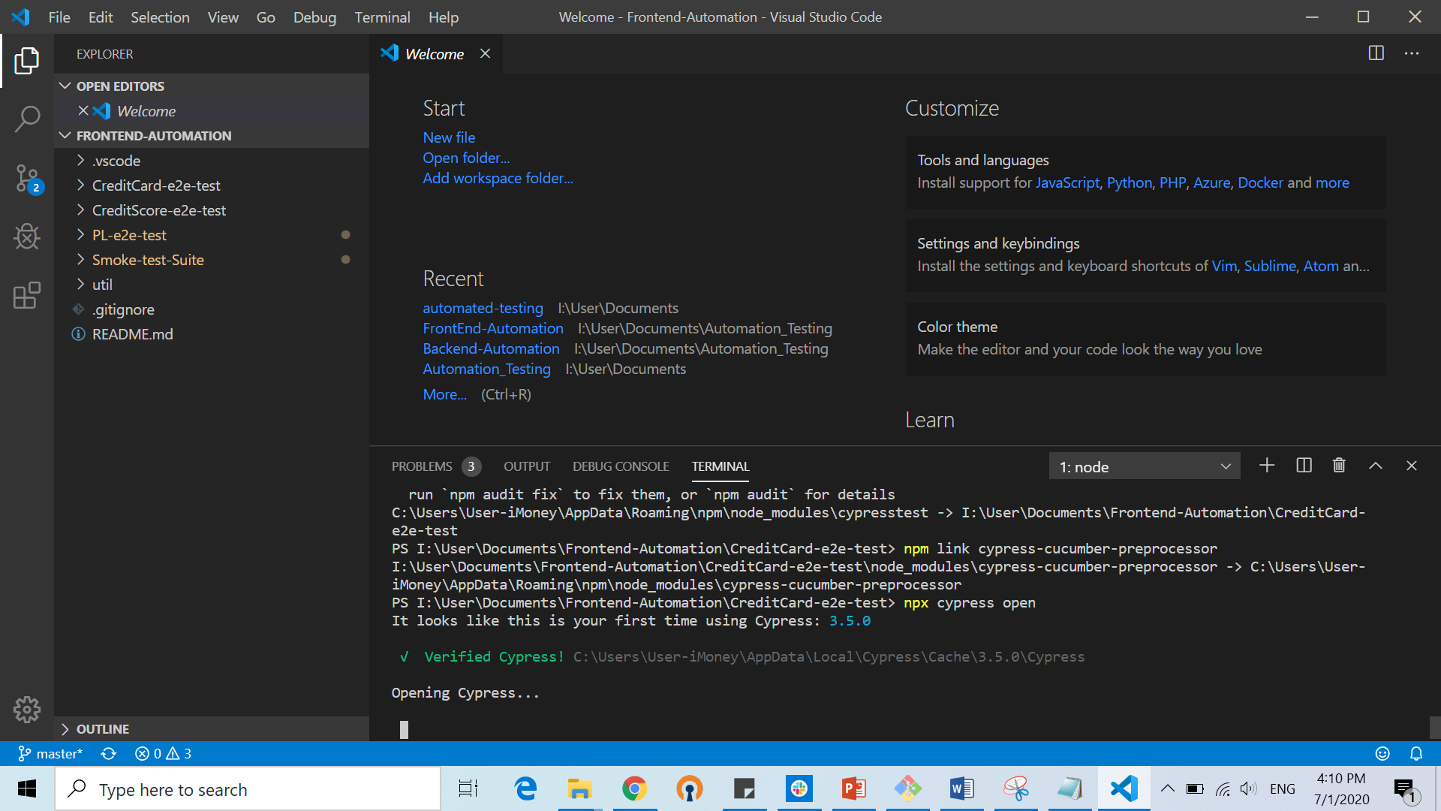

npm install rimraf -g

rimraf node_modules (to remove node modules)